**Test Strategy**



Version -6.5.201

23/06/2021

**Document Control:**

**Document Details:**

| Title | Test Strategy document of Unacademy |
| --- | --- |
| Version | 6.5.201 |
| Date | 23/06/2021 |
| File Name | Unacademy-Test Strategy |
| File Location | https://drive.google.com/folderview?id=1Cd-CByUsL4U21nYnRNhAOOXDmvOhp40f |
| Author | Ramya, Dilliganesh ,Priyanka ,Dhinesh kumar |
| Contributor | AnuMeha mam |

**Change Control:**

| Issue Date | Updated on | Version | Details | Author |
| --- | --- | --- | --- | --- |
| 15/02/2017 | 12/07/2021 | 6.5.201 | <Working Draft>, <Reviewed> | Ramya |

**Document Reference:**

| Document Name | File Location |
| --- | --- |
| Unacademy-Requirement traceability matrix | https://drive.google.com/folderview?id=1Cd-CByUsL4U21nYnRNhAOOXDmvOhp40f |
| Test case design | https://drive.google.com/folderview?id=1Cd-CByUsL4U21nYnRNhAOOXDmvOhp40f |

Contents

1. Scope and overview 4

2.Test Approach 4

3. Test Levels 5

4. Test Types 5

5. Roles and Responsibilities 5

6. Environment requirements 6

7.Testing tools 6

8.Industry standards to follow 6

9.Test deliverables 7

10.Testing metrics 7

11.Requirement Traceability Matrix 8

12.Risk and mitigation 9

13.Reporting tool 10

14 Test summary 10

15. Approvals 11

# 1. Scope and overview:

# Creating a new Application which offers Learning and  providing quality pedagogy for aspirants preparing for competitive exams. In scope is Functional testing in that application.

# 2.Test Approach:

# 

| **Tester** | **Module** | **Time** | **Responsibility** |
| --- | --- | --- | --- |
| Ramya | Sign Up,login | 3hrs | Complete Functionality testing of Login |
| Dilliganesh | Manage goals | 3hrs | Complete Functionality testing of Manage goals |
| Dinesh kumar | Syllabus,Tests | 3hrs | Complete Functionality testing of Syllabus and Tests |
| Priya | Payment | 3hrs | Complete Functionality testing of Payment |

# 3. Test Levels:

# Levels of testing such as unit testing, integration testing, system testing and user acceptance testing,smoke testing, retesting.

# 

# 4. Test Types:

Functional testing will be performed during Manual Testing. Black box Testing tests each model with all possiblity of inputs and outputs and there result.To check this actual output with expected output.

# 

# 5. Roles and Responsibilities

| **Role** | **Responsibilities** |
| --- | --- |
| Project Manger | AnuMeha mam |
| Project Lead | Ramya |
| QA | Dilliganesh,Priyanka,Dhinesh Kumar |

# 6. Environment requirements:

# Hardware Requirements

O/S : Windows 10.

Processor : 1 GHz,intel i3.

Ram : 100 Mb.

Hard Disk : 1 Gb

Software Requirements

Browser : Any browser

# 

# 7. Testing tools:

# Not Applicable

# 8. Industry standards to follow:

This section describes the industry standard to produce high quality system that meets or exceeds customer expectations.

* IEEE- Standard for Software Test Documentation-This documentation should be follow during developing high quality software. IEEE series defines an internationally-agreed set of standards for software testing of software testing standards.
* The main purpose of the IEEE series is to provide such guidelines that can be used by any organization when performing any form of software testing. They should follow some documents that documents should provide requirements, specifications, guidelines, or characteristics that can be used consistently to ensure that materials, products, processes, and services are fit for their purpose.

# 9. Test deliverables:

# List of all the test deliverables

1. Before Testing Phase:

* Test plan documents
* Test cases documents
* Test Design specifications

2. During the Testing:

* Test scripts
* Error logs and Execution logs
* Test Data
* Test Traceability Matrix

3. After Testing:

* Test Results/Reports
* Defect Report
* Installation/Test procedures guidelines
* Release notes

# 10. Testing metrics:

# Software testing metrics - Improves the efficiency and effectiveness of a software testing process

Some of these QA metrics examples are:

* Number of tests in a certain time period = Number of tests run/Total time.
* Test design efficiency = Number of tests designed/Total time.
* Test review efficiency = Number of tests reviewed/Total time.
* Number of bugs per test = Total number of defects/Total number of tests.

# 11. Requirement Traceability Matrix:

# Requirement traceability matrix is used to trace the requirements to the tests that are needed to verify whether the requirements are fulfilled.

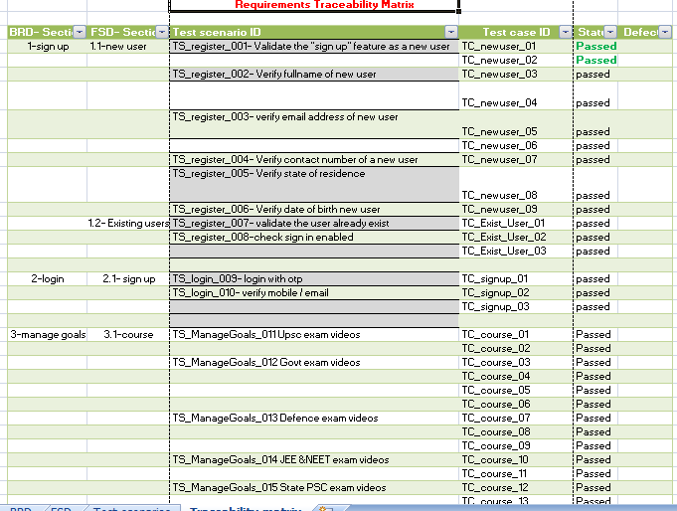

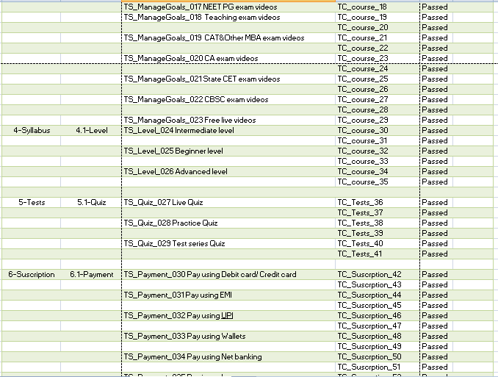

# 

# 12. Risk and mitigation

| **S.No** | **Risk** | **Mitigation Plan** | **Impact** |
| --- | --- | --- | --- |
| 1. | Business Risk | Select the Low paid courses | Financial effect |
| 2. | No Technical courses | Choose other application for technical | Subscribers lost |
| 3. | High competition | Due to the Government exam courses it may have high competition | High time and effort may lead to high time complexity & duration |

# 13. Reporting tool:

# Not Applicable

# 14. Test summary:

# Summary: Application is to learn any new Courses .

Step 1: log in to the application with Sign up/Sign in

Step 2: Click on the login details

Step 3: we login to the application, our profile has been visible

Step 4: Search the course and select the course which their preference

Step 5: Take live classes and select Syllabus(Level) they need

Step 6: Attend mock tests, Interact top Educators

Step 7: Make payment for selected course & save the course details for remind to be later.

Step 8: If they needed free course that should be available

# 

# 15. Approvals:

The following people are required to approve the Test Strategy

| **Approved By Role** | **Approved By Name** |
| --- | --- |
| Business Team | AnuMeha mam |
| Testing Team | Dilliganesh, Dinesh Kumar |
| Development Team | Ramya, Priyanka |